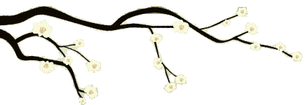 ***Pleasant Events Calendar***

Be aware of a pleasant event *at the time it is happening*. Use the following questions to focus your awareness on the details of the experience as it is happening. Take time to write it down later.

|  |  |  |  |  |
| --- | --- | --- | --- | --- |
| **What was the experience?** | **Were you aware of the pleasant feelings *while* the event was happening?** | **How did your body feel, in detail, during this experience?** | **What moods, feelings and thoughts accompanied this event?** | **What thoughts are in your mind now as you write this down?** |
| Hearing a bird sing | Yes | Lightness across my face, aware of shoulders dropping, corners of mouth lifting | Relief, pleasure. “That’s good.” “How lovely (about the bird).” “It’s so nice to be outside.” | It was such a small thing but I’m glad I noticed it. |
| Friday |  |  |  |  |
| Saturday |  |  |  |  |
| Sunday |  |  |  |  |
| Monday |  |  |  |  |
| Tuesday |  |  |  |  |
| Wednesday |  |  |  |  |
| Thursday |  |  |  |  |